United Kingdom Armed Forces Association Of Cricket Officials

Annual General Meeting Held on Friday 8th April 2022 at 1400 Hrs

At HMS Nelson, Portsmouth

Agenda

Item | Subject | Lead
 | Meeting opened at : 1420  Present – 21  Minutes – Proposed By: Linda Judd  Seconded By: Ben Linnell  Carried  Welcome – The secretary opened the meeting and apologised for The Chairman being unavailable at the last minute due to his role in MOD Main Building. | Secretary
1 | Chairman  Please see the Chairmans welcoming address and opening remarks at the end of these minutes.  United Kingdom Armed Forces Association of Cricket Officials Chairman’s Update  A largely full cricket season in 2021 saw appointments and support to Service cricket return within UKAF ACO after COVID. The opportunities for development of newer officials began with a mentor programme in place and a full, online umpire course delivered in Apr. This has given us further flex in training new officials and the next step is to formalise a scorer option within the Services over the 2021/22 winter. Discipline issues were a concern in 2021 and one SP was formally reprimanded using the UKAF Code of Conduct. | Chairman, Sec
2 | Secretary  - Thank You – Thank you to everyone for all of your work last season and preparation for this season. Also a huge thanks to Steve Blackburn, Glenn Duggan and Andy Scarlett for their efforts this morning.  - Membership – Update on numbers post last seasons review - 106  - Total: Military Members – 64  - Total: Civilian Members – 40  - Total: Life Members - 2  - Committee – As per the constitution the committee all stood down prior to the AGM and put themselves forward again for the same posts. These positions were then voted for. All committee members were voted back into the same positions except Performance.  Chairman – Christian Nicholson  Secretary – Alex Rennie  Treasurer – Nick Soloman  Education – Glenn Duggan  Education – Simon Mellor -  Performance – Martin Seward  Clothing – George Horne – Requires a Serving Replacement.  Umpires Appointments – Gary Eustace  Umpires Appointments Assistant – Dave Young  Scorers Appointments – Richard Isaacs  Welfare Officer – John Bowra  Social Media – Richard Issacs  Social Member – Linda Judd  Navy Representative – Steve Blackburn – Voted in at AGM (Carried)  Army Representative – Sarvjit Singh  RAF Representative – Ben Linnell  Civilian Representative – George Horne  - New Sub Committee – UKAF ACO have set up a new sub committee to ensure playing regulations, rules, law changes and discipline are maintained to the correct standard.  - Returns and contact from Secretary – It was mentioned that as an ACO the membership needs to confirm attendance to meetings using emails or social media in a timely manner. Please ensure that the secretary has the correct contact details.  - Social Media Sites – The UKAF ACO is very active on Social Media and also on the web with our UKAF ACO Website. Members are encouraged to Tweet and comment on Facebook. The Chairman would just like to point out that as an ACO we must remain impartial. A further brief about social media will be given later in the AGM. As per MOD Guidelines there are to be no posts mentioning the situation in the Ukraine.  - Regulations – All match regulations will be published on the UKAF ACO website and also in the INEX Folder on WTU. All members are requested to ensure you arrive at the match with the correct 2022 Regulations.  - COVID – ECB Return To Play Roadmap Level 4. | Sec
3 | Financial update and sponsorship  - Sponsorship for this year will continue from Avon Protection  - Any other sponsorship details would be great. If you know of anyone or firms interested please pass them onto the Secretary.  - Update on UKAF ACO Finances: Nick to provide  - It was mentioned that Payments to our civilian members who submit claims should be paid faster, this will be looked into.  - Match Fees – Match fees will be increased in 2022. The figures will be distributed once agreed.  - Details For Membership Payments:  Membership Payments:  If members wish to become Active members they are requested to send a £10 BACS transfer to  Sort Code: 30-94-47,  Account Number: 00257553  Account Name: RAF Cricket Umpires Scorers Association  Ref: Please insert your surname.  Payments are to be sent by 31 May 202 | Chairman, Sec
4 | Appointments - Umpires  - WTU INEX. On WTU there is a folder called INEX. In here you will find helpful information and also UKAF ACO specific documentation. Items like Competition Regs, Payment Invoice Forms, Match Reports, Pitch Reports etc. Please check the INEX.  - Full Report at the end of these AGM Minutes.  - Umpires will only be allocated if they are on WTU.  - Umpire allocation priority will be as follows:  - Serving Member in close location  - Ex Serving Member from any location  - UKAF ACO Civilian in close location  - UKAF ACO Civilian from any location  - Umpire from County ACO if no UKAF are available  Scorers Appointments Member  - Richard Isaacs is the appointments member for ALL scorers allocations to all UKAF ACO matches.  - If any member would like recommend friends to scoring within UKAF please pass on any details to Richard.  - Key concern is lack of military scorers and limited number of UKAF ACO civilians. Big push to get more scorers. Any initiatives to recruit would be great.  - Play Cricket – Adopted now across UKAFCA. Please ensure all scorers are up to speed on the system.  - Inter Corps Power Cup. As per last year each Corps will provide a scorer for their matches. Umpires are to note their names at the start of each game and pass them onto Richard Issacs. If no scorer is provided that corps will receive 10 penalty points. Richard is to follow up by contacting the names provided.  - Tours. It was mentioned that if a SS or Corps goes on tour that the UKAF ACO be made aware so that the right level of Umpire and Scorer can be allocated to the tour or recommended to the Tour Captain. | Appointments Member (Umpires)  Appointments Member (Scorers)
5 | Education  - Online scorers’ course – https://booking.ecb.co.uk/c/express/b3ff5124-d7fd-4e6b-acb4-806ca3d33e56  Full Report at the end of these minutes. | Education Officer
6 | Performance  - As you may be aware Martin is deployed in a really busy role in Cyprus. He has apologised for not being around much.  - 2022 Umpire Panels – The chairman would like to congratulate the members who are on the Full panel and Development panel for 2022. There have been a number of changes this season which have included more civilian members being added. The Panels were shown at the AGM and can be viewed at the end of these meeting minutes.  - There are changes to the Umpire Pathway PD development. These will be reviewed and then introduced during the season. This will be distributed when ready.  - If anyone is interested in progressing to the next level please inform Martin or the secretary and we will assign a mentor and start your PD process.  - All umpires – Please remember to complete ECB ACO paperwork for all games you stand in. Pre Match, Post Match reflections etc.  - From the floor during AGM – Request that any Captains reports be shared with the umpires once they have been received. | Performance Officer
7 | Safeguarding Officer  - Anyone requiring CRB updates needs to speak to the Safeguarding Officer (John Bowra)  - DBS initiating - ECB | Safeguarding Officer
8 | Media / Social Media  - The media rep for UKAF ACO is Richard Isaacs. He is currently updating our Website and a NEW website will be online in a few weeks.  - As per MOD guidelines there are to be no SM posts regarding the current situation in the Ukraine.  - Social Medial links are as follows:  - Facebook - https://www.facebook.com/UKAFcricket/  - Twitter - https://twitter.com/UKAF_ACO  - Web - https://ukaf-aco.com/  - The UKAF ACO web page is your 1 stop shop. It has match regulations, invoice forms, WTU appointments and lots of other info.  - Please can members who have been on tours share a small report with pictures that can be posted on the website. | Media Officer
9 | Clothing Member  - Serious Cricket have set up a UKAF ACO Web shop and members can purchase at great prices UKAF ACO branded equipment clothing. This includes jackets for bad weather. Details of the web shop are at this email address: https://seriouscricket.co.uk/teamwear/stores/ukaf-aco  - Clothing will only be issued once you have a game confirmed on WTU.  - It has been mentioned by several members that the new SC Umpire Shirts do not have a breast pocket. This is not something that will be available. The secretary apologised but due to the huge reductions in costs SC are the UKAF ACO supplier. It has been investigated and SC are not in a position to add a breast pocket.  - Kit Allocation – All Active Members will receive 2 FREE items of kit:  - Umpires – 1 x White Match Shirt & 1 x Black T20 Shirt  - Scorers – 1 x UKAF ACO Polo Shirt & 1 x UKAF ACO Warm Top  Any additional items can be purchased on the SC UKAF ACO Web shop. Umpires will not be issued on field jackets – however SC do offer both white and black umpire jackets at a really good price. It is worth noting that UKAF ACO receives discounted price every season depending on how much is sold each year. | Clothing Member
10 | Social Member  - BBQ mid season Date TBC  - End of Season dinner on HMS Victory – possibly September  - A big thank you from the ACO for Linda for arranging the AGM Venue and the social dinner this evening. | Social Secretary
10 | Single Service Reps  The secretary will arrange a call with all SS Reps to discuss ways of working and challenges. This will be done before the season starts. The secretary will also send an update list of members to all SS Reps. It was also discussed that as part of UKAF policy that when overseas tours are taking place an Official must be part of the touring party. This should be mentioned in communications to any unit organising a tour. Ben Hood has just got back from Barbados where he toured with the AGC Cricket team.  Navy  - Stephen Blackburn volunteered his services to act as the RN Single Service Rep.  - No other comments.  Army  It was great to see a successful session of cricket despite the Covid restrictions. Thank you to everyone who have supported and made things flowless for the previous season. Hoping to receive the same support for the upcoming season. Please see below my points. Some of the points are extracted from the ACA AGM to raise awareness and highlight the importance.  Army Cricket Handbook. MT reported that the current Army Cricket Handbook (ACH) was updated for the 2021 season and remains extant. Corps should use the ACH as a source of advice and guidance. It is suggested that the latest version will be circulated before the start of the season.  Corps Contact List. Corps Secs are requested to ensure their respective details are kept up to date. Hopefully this would benefit the officials to raise any enquiry in timely manner.  Discipline, Behaviour and Standards. There was a noticeable deterioration in behaviour in some areas across military cricket last season. A note from Brig Matt Cansdale was sent to all the Corps chairperson to reiterate that highest standards of behaviour are demanded, and transgressions will not be tolerated.  Discounts Gray-Nicolls and Woodstock. Gray-Nicolls and Woodstock are offering discount. If anyone require the code, please get in touch with the Army Rep.  COVID. AR thanked all Corps Reps for helping to facilitate cricket in a safe manner throughout the COVID affected season. AR is tracking the ECB for any developments or changes in the COVID protocols (currently at Step 4) and any new information will be captured within the SSMP.  Sport Safety Management Plan. The latest version of the COVID compliant ACA Sport Safety Management Plan (SSMP) is being updated and will be promulgated before the start of the new season.  Pitch Reports. Corps are requested to ensure any issues with pitches are discussed with the match umpires and included in their post-match reports. This will be used to help hold contractors to account for maintenance.  Feedback Forms. Corps are to ensure that they complete feedback on Umpires. ACO will promulgate details of these match reports which can also be found on the INEX Section of Who’s the Umpire (WTU) and the ACO website.  Home Grounds. All Corps are to keep details of their Home Grounds up to date on the contact list and to inform MT of any changes. For 2022, REME will continue to share use of Larkhill and the RLC and AGC will both use Worthy Down. For the Power Cup, if unavoidable and both sides agree, the designated ‘Home’ Team can play ‘Away’ but will cover any associated costs. Where possible, shared home grounds have been factored into Power Cup fixtures.  Finally, looking forward to a great season ahead and standing in with most of you in as many as games I can.  RAF  - Ben introduced himself and mentioned that he has finally got engagement with the RAF Cricket Association and will be discussing RAF Umpire and Scorer issues. His intention is to promote awareness and will be contacting RAF Gyms via PTI’s.  - The Training Team are requested to provide a poster showing future course dates and how people can register interest so that it can be distributed through RAF Channels.  Civilian  - George thanked all of the members for their support last year and also thanked them for their support to him personally.  - He will be reaching out to all civilian members in the next few days. | SS Reps
11 | AOB  - See attached info regarding new MCC Law Changes - https://www.lords.org/lords/news-stories/mcc-announces-new-code-of-laws-from-1-october-2022  - Payment of Claims – See Finances area.  - Sharing of Feedback Forms / Captains Reports – See Performance  - Squad Lists for Play Cricket – SS Reps are requested to get their associations to provide provisional squad lists to Richard ASAP so squads can be entered on Play Cricket.  - Wet Weather – Confirm if umpires travel during wet weather. Current guidance is yes. Only a qualified umpire can call off a game due to wet weather.  - WTU Details – SS Reps are requested to reach out to their associations to ensure all WTU Contact details are updated with correct contacts for each match and the Team Manager / Captain sends a match Admin Instruction to the Umpires and scorers allocated on WTU. It is also recommended that Umpires and scorers also contact the Match manager as soon as you are allocated.  - Review of Umpire Allocations – It was mentioned from the floor if the allocation of FULL PANEL Umpires could be reviewed. This is in relation to appointing civilians as a higher priority so that the best officials are allocated to high priority games. This is brought a long discussion with some very good reasons for both for and against. The secretary mention that this policy is set by UKAFCA and follows the guidelines for promoting military sport and any changes would require UKAFCA approval. This will be mentioned to the chairman and any further communications will be forwarded to all members. | Sec
12 | Diary Dates  - 10 - 12 May: Army Inter Corps T20  - 09 June: Inter Services DEV T20 – Vine Lane  - 14 June: Inter Services T20 – Day 1  - 16 June: Inter Services T20 – Day 2 – Lords  - 29 June: Ladies Inter Services T20 – Arundel  - 25 – 27 July : Ladies Inter Services Festival – Portsmouth  - 1 – 3 August: Mens Inter Services Festival – Aldershot  - October: UKAF ACO ECM – Date and Timings TBC

2022 UKAF Panel Details:

UKAF Panel (UKAF P)

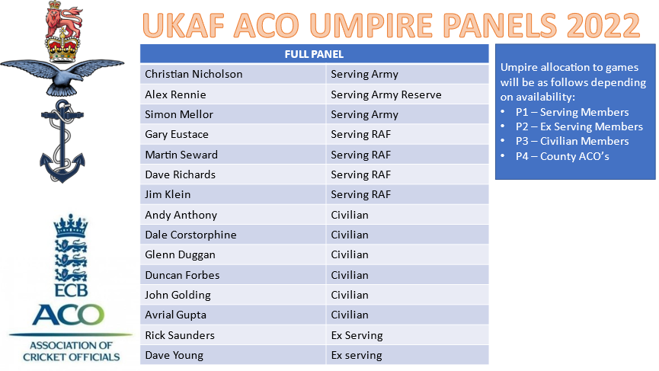

UKAF Development Panel (UKAF DP)

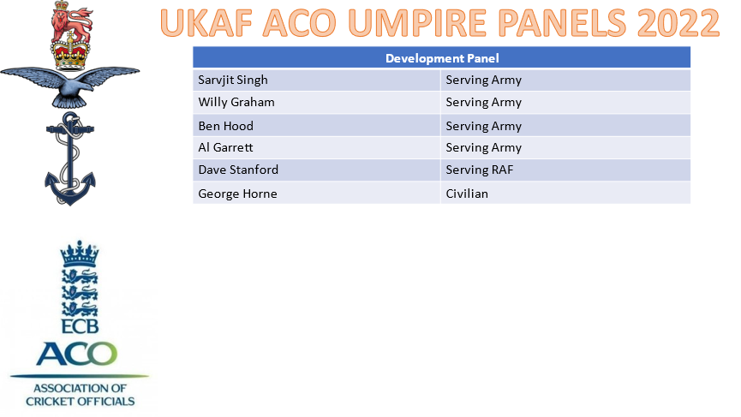

United Kingdom Armed Forces Association of Cricket Officials Chairman’s Update

A largely full cricket season in 2021 saw appointments and support to Service cricket return within UKAF ACO after COVID. The opportunities for development of newer officials began with a mentor programme in place and a full, online umpire course delivered in Apr. This has given us further flex in training new officials and the next step is to formalise a scorer option within the Services over the 2021/22 winter. Discipline issues were a concern in 2021 and one SP was formally reprimanded using the UKAF Code of Conduct.

As everyone has continued to tip toe through the regulations and restrictions following COVID many members of the committee have worked incredibly hard to ensure we launch into the 2022 season in excellent order. Glenn and Si have done an amazing job juggling courses (and candidates) on training opportunities to ensure our ranks continue to swell. The initiative for our first UKAF ACO scorers’ course to be delivered in 2022 is a significant moment. The first winter of our newly formed regulations committee has proved successful and all regulations will now be comfortably in place, having been circulated around each Service, before the season start. Our appointments team are already rapidly filling the matches as they come in which must feel like a never-ending job, thankfully they are masters at it. I have had a sneak peek at our refreshed website, and it is looking great! Another volunteer who does the work in his own time and in addition to some pretty busy (and distant) schedules. Our newly created social member has got us off to a flying start and this evening we (I hope including me!) will enjoy a delicious meal with excellent company. And a round up of our season and winter would not be complete without our honourable and long-suffering secretary! While holding down a full-time role in a global company and an active Army reservist, continues to keep us all on the straight and narrow. To Alex and everyone who continue to support our association my heartfelt and ongoing thanks to you all.

Many will be aware of the small number of incidents of ill-discipline on field last season. I hope these were a one off and we will see a return to normal, high standards. There has been full and encompassing support from each of the three Services to encourage this. As officials, we of course must ensure two things:
1. That we are at the top of our game when officiating any match and when the standard unexpectedly falls below our own high standards, we are humble enough to show contrition and to learn.
2. To ensure any drop in player behaviour is acted upon swiftly and appropriately. Not all occasions require an officious Sergeant Major style and forms to be completed (when a quiet word and a reminder of expected behaviour may suffice). But some do, and they must.
The updated Code of Conduct, the UKAFCA constitution and the UKAF ACO committee will support you all throughout and need only be asked.

The AGM and annual (until recently!) dinner have usually been the place where the Mal Miller and Ned Kelly awards are awarded but this year will see a slight change, I hope for the better. With the appointment of a new social member and our gathering previously being limited to once a year, it is planned to hold a second social event at the end of the season where both awards will be presented, hopefully with both Mal and Barbara in attendance to present them.

Our newly refreshed website will be the one stop shop for all your UKAF ACO needs and if it is not then please let us know! The aim is to ensure ease of access for all. The 2022 season regulations will be uploaded in the coming days along with other useful information. If there is anything you feel would benefit from being on there, again please let us know.

The events of Ukraine have of course fixed many of us, my own absence a prime example, and I hope that it does not affect any of you or your families adversely. As we emerge from COVID I hope you all remain safe and healthy, too.

Finally, I wish you all a hugely successful season in 2022. May your signals be clear and your paddle waves met with a nod. Keep safety of everyone involved at the forefront of your minds but most of all, enjoy every delivery!
Christian Nicholson

Umpires Appointments Report:

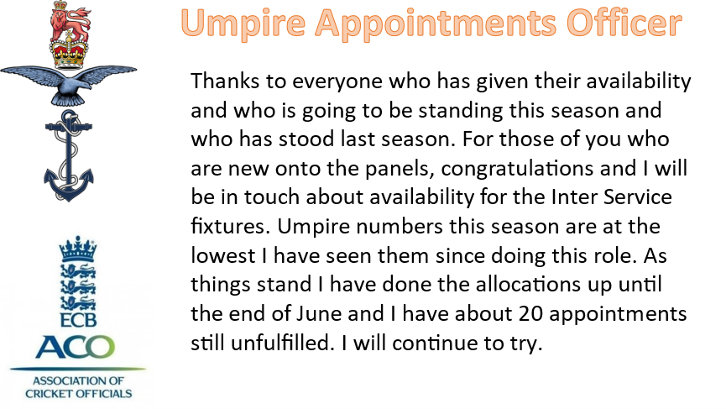

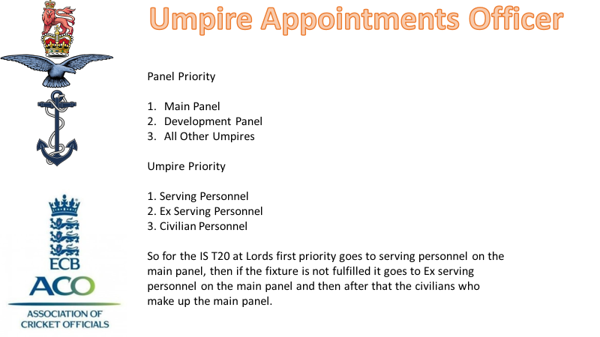
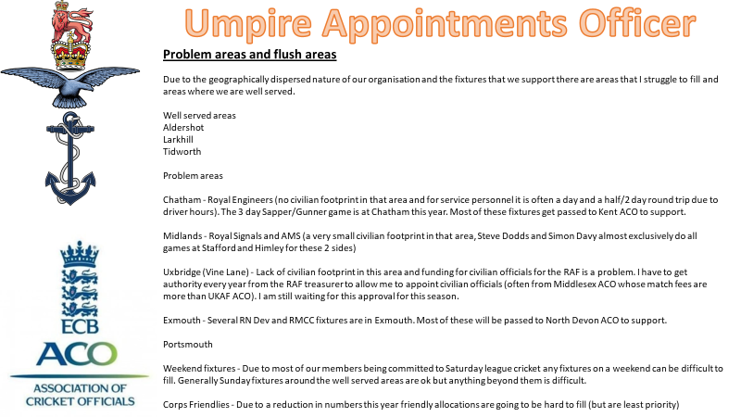

UKAF ACO Training & Education Report – March 2022
This is my third report to the UKAF ACO AGM since taking over the Head of Training and Education role in 2020. The Panel of Tutors has now increased from 9 to 12 with 5 Serving (4 Army, 1 RAF), 4 Ex Serving (2 RN, 1 RAF and 1 Army) and 3 Civilian Tutors. Two of the Panel are being utilised as Tutors but will need to qualify as Tutors with the ECB when courses become available.
I am pleased to report that the transformation of training from 3 individual services to bring the training under the ECB ACO/UKAF ACO has been successful.
Simon Mellor and I have worked well as a team with the help of the Chairman who is also a Tutor. Simon has generally managed the training equipment and I have concentrated on the planning and implementation of Training.
Course Planning - Update
The idea for each service to host one umpire course each year has been tried and has proved rather difficult to implement. Communications with the RAF have been difficult and there has been a reluctance to host a course because of a perceived lack of RAF venues. The Royal Navy are willing to host one course each year with HMS Temeraire’s Sports Lottery accommodation ideal in providing both classrooms and accommodation in the one location. Planning and implementation of a Face-to-Face Stage 2 course was in an advance stage but had to be cancelled in early January when the Sports Lottery Accommodation was allocated to RN Personnel suffering from Covid-19. This highlights the fact that no certainty can be given when booking this venue. Unfortunately, the umpire’s course is considered low priority and the booking of this venue will always be subject to uncertainty as other organisations have a higher priority. This along with the current lack of interest from RN personnel means that it is not currently an attractive proposition when planning a course hosted by the Royal Navy.
The Army however are well organised when it comes to the provision of sports courses with the Army School of PT providing excellent administration and facilities. It has therefore been decided that to save any future nugatory work that an approach to the Army to reverting to host 2 courses each year at Aldershot be made which will be open to all 3 services. An initial approach has been made to the Army for that second course to be re-instated in 2023 and this will be considered at the Army’s Sports Training Planning Meeting scheduled for October this year.
If the demand exists in the future we could arrange an online Stage 2 Course at short notice for an individual service or on a tri-service basis.
The initial plan of creating a 4-day combined Stage 1 & 2 Umpires Course with a 1-day Scorers Course added on with candidates wanting to qualify as Scorers attending that last day and the umpire candidates staying on for that last day to qualify as scorers has not been proceeded with for various reasons namely; a. To qualify as a Scorer and Umpire would have to pay an additional fee of £30 to the ECB. b. One day is not enough to run the Scorers Course. c. The 5th day is required for the Umpires Course to enable to provision of a practical day for umpire candidates called “Are you ready to call ‘play’” which rounds off what trainee umpires have learnt in the classroom in the first 4 days of the course. This training day is considered invaluable for students by Tutors.
At the same time, we are taking the opportunity of modifying the umpire’s course by asking candidates to undertake the Stage 1 online course offered by the ECB which is free of charge as a pre-requisite for attending the Face-to-Face Stage 2 course. We feel the benefit is that candidates can learn the laws of the game in their own time whilst at the same time showing that they have a commitment to cricket umpiring. It also allows us to carry out revision of Stage 1 on day 1 and then move on to Stage 2 for days 2-4 culminating in the one-day practical course. A further advantage to students is that it is £10 cheaper in respect of course fees.
Courses Completed
I am delighted to report that UKAF ACO Tutors have successfully run 4 Courses in 2021. Two of those courses were Stage 2 online courses held in March and early April each weekend for 2 to 3 hours for 5 weeks. The Tutors were Glenn Duggan, Christian Nicholson, Simon Mellor and Ian Royle. 15 umpires qualified on these two courses (3 RN and 1 Army and 11 civilians from Hampshire). A further 2 Army Umpires qualified with Oxfordshire (they were not available for the UKAF ACO Courses) and they attended a specially arranged one day online course with UKAF ACO Tutors.
A one-day course “Are you ready to call Play?” was arranged at Burnaby Road Portsmouth for all those who had qualified on-line with invitations to those who had qualified on courses when “lockdown” had followed to act as a refresher. 8 umpires attended the course which took them through various on field scenarios. Both Tutors and Students felt that this day is essential for any newly qualified umpire and even a refresher for the more experienced official. The Tutors were Glenn Duggan, Christian Nicholson and Simon Mellor with Lloyd Priest assisting.
The 4th course of the year was a Face-to-Face Combined Stage 1&2 Course held at the Cricket Pavilion at Aldershot between 11th and 15th October. Again, the Tutors were Glenn Duggan, Christian Nicholson and Simon Mellor. We asked all candidates to complete the online Stage 1 Course and a good majority of the 12 who completed the course had done so. There were 11 Army students and one RAF. Because of numbers and Covid and the ambience of the rooms the upstairs of the pavilion were utilised. The downside was that viewing the screen was sometimes difficult because of the daylight in the room. The group were a delight to teach, and it is hoped that several of those qualifying will go on to be established UKAF ACO umpires.
In summary 28 candidates have qualified umpires under UKAF ACO Tutoring this year (14 Army, 2 Royal Navy, 1 RAF and 11 civilians) and a further 8 qualified umpires further trained. So, in summary a good training year for the UKAF ACO with 4 courses run and 28 umpires trained albeit 11 of those umpires trained are not armed forces personnel. Although those 11 will have brought in just over £200 into funds through payments made by the ECB ACO. In addition, a Mentoring System has been established with those recently qualified asked if they would like to have a Mentor allocated to them. If they do, then their details are passed to the Chairman who allocates a Mentor to them.
Publicity for Officials Courses
Problems continue in the publishing of courses through DINs. Extensive work has been undertaken and the Army have an excellent system of reaching people through advertising on sports notice boards and using MOD Net for booking the courses through the Army School of PT. There has been some issues recently raised over advertising and Simon Mellor is looking into this. The Royal Navy does not appear to have such a good system and certainly the advertising on sports notice boards is not as good as the Army. Although I have no information currently on the RAF advertising system. I have had several interested RAF personnel contact me so there is some system in place.
Equipment Update
Simon Mellor has done an excellent job in pulling together the various items required for training umpires. It is always necessary for Tutors to provide additional items as teaching aids and there has been a reliance to date for Tutors to provide their own laptops and projectors. I am delighted to report that the Chairman has approved the purchasing of a UKAF ACO laptop and projector and Simon Mellor is sourcing that equipment.
The advantage of using Aldershot Cricket Pavilion for training courses is that all the equipment can be securely stored at that facility and will not require to be moved around from venue to venue.
Future Courses Planned
We are holding a Training/Education session in the morning of 8 April in Portsmouth in advance of the AGM in the afternoon. The content of the morning is being worked on but will be of interest to all umpires and scorers to help improve their performance and development. It is hoped that there will be two different programmes one for umpires and one for scorers.
The next face to face Stage 2 Course will take place at Aldershot in October between 24 – 28 October 22. The candidates who had the January course at HMS Temeraire cancelled (6 in number) will have priority booking on this course.
Scorers Courses
Mike Cornwall is the Tutor lead for Scorers Courses but we are short of experienced Scorer Tutors and we have recruited a very experienced Tutor in Andy Scarlett. Andy is Ex RAF and he will be helping us establish Scorers Training. We explored whether the Club Scorers Course could be held over one day, but two days is the ideal length with a third day dedicated to computer scoring. At present there is no Scorers Courses arranged and an approach has been made to the Army to see whether they would be prepared to fund and host a course at Aldershot in 2023. This will be discussed at the Army’s October Training Meeting, and it is hoped that this receives approval.
Summary
A lot has been achieved in the last 12 months and I believe UKAF ACO Training & Education is in a good place at present.
-------------------------------------------------------------------------------------------------------------------------

MCC Law Changes – October 2022

https://www.lords.org/lords/news-stories/mcc-announces-new-code-of-laws-from-1-october-2022

Those that are not keen on clicking links it says:

MCC HAS TODAY ANNOUNCED ITS NEW CODE OF LAWS FOR 2022, WHICH WILL COME INTO FORCE FROM 1 OCTOBER.
The alterations to the Laws of Cricket in October 2017 were the most significant that have been made for almost two decades.

The code was well received and has had a positive impact on cricket all over the world, but even in the five years since publication, the game has evolved and the MCC Laws sub-committee has suggested several changes for the 2022 Code, which were subsequently approved at the Club’s Main Committee meeting last week.

Whilst the amendments are being announced now, they will not come into force until October. However, in the intervening time the relevant materials will be updated by MCC to assist with umpire and official training on a global basis. The changes are intended to shape the game of cricket as it should be played.

There are several notable changes, as below:

Law 1 – Replacement players

The introduction of a new clause, Law 1.3, explains that replacements are to be treated as if they were the player they replaced, inheriting any sanctions or dismissals that player has done in that match.

Law 18 – Batters returning when Caught

First trialled by the ECB in The Hundred at the suggestion of MCC, Law 18.11 has now been changed so that, when a batter is out Caught, the new batter shall come in at the end the striker was at, i.e. to face the next ball (unless it is the end of an over).

Law 20.4.2.12 – Dead ball

The new edition sees several changes to the Dead ball Law, the most significant of which is the calling of Dead ball if either side is disadvantaged by a person, animal or other object within the field of play.

From a pitch invader to a dog running onto the field, sometimes there is outside interference – if this is the case, and it has a material impact on the game, the umpires will call and signal Dead ball.

Law 21.4 – Bowler throwing towards striker’s end before delivery

If a bowler throws the ball in an attempt to run out the striker before entering their delivery stride, it will now be Dead ball. This is an extremely rare scenario, which has until now been called as a No ball.

Law 22.1 – Judging a Wide

In the modern game, batters are, more than ever, moving laterally around the crease before the ball is bowled.

It was felt unfair that a delivery might be called ‘Wide’ if it passes where the batter had stood as the bowler entered his/her delivery stride. Therefore, Law 22.1 has been amended so that a Wide will apply to where the batter is standing, where the striker has stood at any point since the bowler began their run up, and which would also have passed wide of the striker in a normal batting position.

Law 25.8 – striker’s right to play the ball

If the ball should land away from the pitch, the new Law 25.8 allows the striker to play the ball so long as some part of their bat or person remains within the pitch. Should they venture beyond that, the umpire will call and signal Dead ball. As recompense to the batter, any ball which would force them to leave the pitch will also be called No ball.

Laws 27.4 and 28.6 – Unfair movement by the fielding side

Until now, any member of the fielding side who moved unfairly, was punished only with a ‘Dead ball’ – potentially cancelling a perfectly good shot by the batter. Given the action is both unfair and deliberate, it will now see the batting side awarded 5 Penalty runs.

Law 38.3 – moving the running out of the non-striker

Law 41.16 – running out the non-striker – has been moved from Law 41 (Unfair play) to Law 38 (Run out). The wording of the Law remains the same.

Law 41.3 – No saliva

When cricket resumed following the onset of Covid-19, playing conditions were written in most forms of the game stating that applying saliva to the ball was no longer permitted. MCC’s research found that this had little or no impact on the amount of swing the bowlers were getting. Players were using sweat to polish the ball, and this was equally effective.

The new Laws will not permit the use of saliva on the ball, which also removes any grey areas of fielders eating sugary sweets to alter their saliva to apply to the ball. Using saliva will be treated the same way as any other unfair methods of changing the condition of the ball.

"IT IS IMPORTANT THAT WE ANNOUNCE THESE CHANGES NOW AS PART OF THE CLUB’S GLOBAL COMMITMENT TO THE GAME"

Fraser Stewart, MCC Laws Manager, said: “Since the publication of the 2017 Code of the Laws of Cricket, the game has changed in numerous ways. The 2nd edition of that Code, published in 2019, was mostly clarification and minor amendments, but the 2022 Code makes some rather bigger changes, from the way we talk about cricket to the way it’s played.

“It is important that we announce these changes now as part of the Club’s global commitment to the game, giving officials from all over the world the chance to learn under the new Code ahead of the Laws coming into force in October.”

