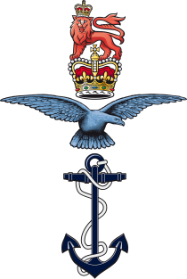
United Kingdom Armed Forces Association of Cricket Officials

Inclusion and Diversity Policy
The United Kingdom Armed Forces Association of Cricket Officials (UKAF ACO - the ‘Panel’) embraces the goal that cricket should be an inclusive and diverse environment and is fully committed to the principle of equality of opportunity in cricket and to ensuring that its members are treated fairly and are able to conduct their activities free from discrimination, harassment or intimidation.
This policy is in addition to all extant MOD Inclusion and Diversity policies and introduced to be applicable to all members of UKAF ACO, military, veteran or civilian alike.
The Panel is committed to supporting its members on a non-discriminatory basis with appointments and advancement being based on qualifications, ability, experience and commitment. Subject to this, the Panel will not discriminate between members on the grounds of age, gender, disability, race, parental or marital status, pregnancy, religion or belief or sexual orientation.
The Panel expects each of its members to behave appropriately and will not tolerate unacceptable behaviour (including bullying, harassment, discrimination, abuse or victimisation of individuals).
The Panel will endeavour to create access and opportunities for all those individuals who wish to participate (provided they are eligible to participate, in its activities) and who meet the Panel’s criteria for membership.
The Panel is committed to the investigation of any claims when brought to its attention, of discrimination, harassment, bullying, abuse or victimisation of an individual, and reserves the right to impose such sanction as it considers appropriate and proportionate, where such is found to be the case.
In the event that any member, volunteer, participant or other person feels that they have suffered discrimination, harassment, bullying, abuse or victimisation by a member or members of the Panel, they should report the matter in writing to the Panel’s Safeguarding Officer.
B HOOD
WO1 Ben Hood
UKAF ACO Chair

Extant Single Service Values and standards policies, JSP 763 – Behaviours and Informal Complaint Resolution and JSP 831 – Redress of Individual Grievances, remain the primary polices for all serving military personnel.

