United Kingdom Armed Forces Association Cricket Officials

Chair:  WO2 A Rennie RIFLES  HQ 38 Bde  Thiepval Barracks  LISBURN  BT28 3NP  Tel: +44 (0)3001653376    alexander.rennie206@mod.gov.uk | 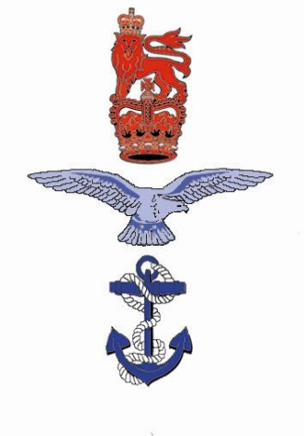 | Secretary:  Major C Nicholson RAMS  Defence Medical Academy  DMS Whittington  LICHFIELD  WS14 9PY  Tel: +44 (0)3001635727  Christian.nicholson352@mod.gov.uk
UKAFACO/AGM/26 |  | Date: 27 March 2026

United Kingdom Armed Forces Association Cricket Officials – Annual General Meeting – 16 April 2026

References:

- JSP 660 – UKAF Sport
- BRd51(4) Chapter 4.
- 2019DIN10-025 - Travel at Public Expense for Army Sport.
- Overview. The United Kingdom Armed Forces Association of Cricket Officials (UKAF ACO) will hold their Annual General Meeting (AGM) on 16 April 2026, commencing at 1300 Hrs. The AGM will be kindly hosted in the Ante Room, Honourable Artillery Company (HAC).

- Administration. The following administrative notes must be noted and adhered to where appropriate. Queries should be directed to the UKAF ACO Secretary.

a. Travel. Travel at public expense to this fixture is authorised iaw Single Service regulations for serving personnel. For RN and Army personnel travel is to be charged to budgets in accordance with Reference C and D respectively. For RAF personnel, travel is chargeable to unit travel budgets. Personnel are to use the most cost-effective means available, including sharing transport where practicable. Personnel are to ensure adherence to Defence Movement and Transport Regulations, specifically those relating to driver fatigue. For aircrew, travel must be considered against the regulations relating to Aircrew Fatigue Management.

b. By Rail. The nearest mainline station is Liverpool Street, a 10-15 min walk from HAC. The nearest tube stations are Moorgate (Northern, Circle, Hammersmith, Metropolitan lines) and Old Street (Northern Line), both around 5 min walk from HAC.

c. By Road. Parking within HAC is not permitted. The nearest car park is NCP Finsbury Park, a 3-4 min walk from HAC. This is located at EC2A 1RR. Those requiring disabled access parking should contact UKAF ACO secretary before 15 April to confirm requirements.

d. HAC Address. The venue is located at Honourable Artillery Company, Armoury House, City Road, London, EC1Y 2BQ.

e. Accommodation. No accommodation has, or will be, requested at HAC. Personnel requiring accommodation they should make their own arrangements via HAC, local units or via HRG using this letter as authority.

f. Physical Attendance. All members planning to physically attend the AGM MUST inform the UKAF ACO secretary of their attendance no later than COP Tuesday 14 April. This must be done via the contact details, below.

g. Online Attendance. The AGM will be simultaneously hosted online. Those members planning to join the meeting MUST inform the UKAF ACO secretary, confirming their email address to be dialled in, NLT COP Tuesday 14 April. A link to join the meeting will then be sent by return email.

3. AGM Business. All UKAF ACO officers are to submit their annual reports to the UKAF ACO secretary NLT COP Friday 10 April. Any matters arising from members must be submitted in writing to the UKAF ACO secretary NLT COP Friday 10 April.

- Timings. The AGM will commence at 1300hrs on 16 April 2026. It is kindly requested that all attending members are seated no later than 1250hrs.

- Security and Incident Management and Reporting. All participants are reminded that security is the responsibility of every individual and is taken very seriously at HAC. Entry to HAC will not be permitted without in date photographic identification aligning to the nominal roll of those attending.

- Points of Contact. Any questions should be addressed to the personnel listed below, as appropriate:

a. AGM General Matters, attendance and matters arising:
Maj Christian Nicholson Christian.nicholson352@mod.gov.uk 07555340712

b. HAC Matters (in extremis):
WO2 Brian Spence RA Brian.spence799@mod.gov.uk 03001670300

{Original Signed}

CLK Nicholson
Major
Secretary UKAF ACO

Distribution: Copy to:

All UKAF ACO members* UKAFCA Sec
HAC WOCIS

